目录
Text2 怎么写 1
提分点： 2
Task1 4
图表 4
地图题 5
流程图 6
自然周期 7
Text1 practice 8
柱状图： 8
饼图 10
折线图 12
表格 13
地图 15
流程图 17
Task2 19
1, discuss both, agree or disagree, advantage, positive trend 19
2, report 21
Report 模板示例 24
Example： 26

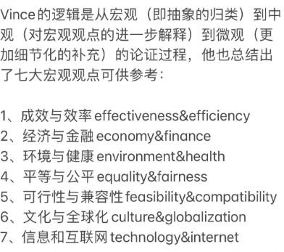
节约时间版：只要看示例就可以，其他不用看
P1-2 是附赠的个人笔记，可以 skip it
论证方法
- 因果 连接词：as,since,the reason why,as a result;as consequences;therefore 人称代词 they，物主代词 their sth 进一步解释 why/reason/consequences代上面整个句子/分论点：This can benefit that…
代分论点的某个事物：most of this/these +n.
- 举例:for example/instance, such as, regardless of whether
- 对比:…while…句内;by contrast
- 类比：similarly，be more likely to，tend to
- 让步:alhough
- 假设虚拟:if..not…;without…not…;..may…;are likely to…;倒装句
- 下定义:This means that,in other words, By this I mean
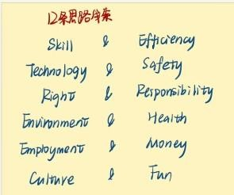
- 特定范围展开:specially,to be more specific,
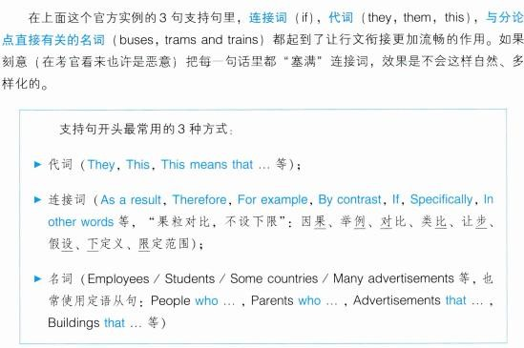

Text2 怎么写

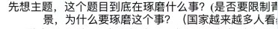
审题：
- 看副词等限定 题干 more and more →突出 decrease/raise 动态
- 看对比.找到两个观点讨论的分歧点。
- 不离题：首段主题直接单词改写，防止跑题，不要改太多。审题看主干。核心词和观点不断扣题，扣限定条件。不断重复，主干段结尾因此要扣题一次

论证：
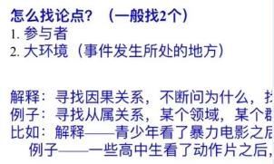

Distinguish between ideas and facts:如果一开始想到的点是事实，则很难展开。所以可以思考这个事实的原因，后果。把后果拿来当论点，这个事实推后当论据:
论点举例：
①支持反对的观点：1，这么做有负面影响+具体说下 2，因为这么做不公平+对谁不公平 3，因为这么做不现实，不可能 unrealistic/even impossible 4 这么做夸大了 blow the things out of proportion 低估了效果作用影响,
②完全赞成：1，为什么做 A，A 的好处 2，为什么不做A 的替代，列出缺点
→论点（+可选展开：解释论证方法 78/或者把论点中的动词，抽象名词，复数名词都解释一遍。再后续论证）。 分析：generally speaking 背景（社会情况，人群现状）→理论论证：主体做了什么，有什么影响→论证方法 6/论证方法 3 对比（当文章出现比较级或者对比的对象时）；或→举例论证：具体说，举例
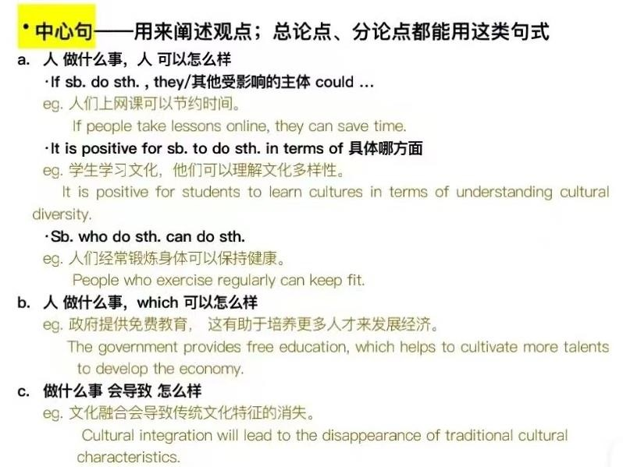
→因此，我认为 细化论点，并扣题→（凑字：论证方法 6）
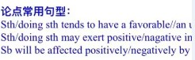
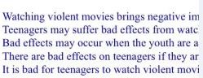
↑换了 3 个主语（人物 doing）+there be
+it is adj for sb. To do/it is adj. that
还有+who 分词 doing/done 做定语
+which 和分词 doing 表结果
+主从 what interest sb. 强调句、让步状语
+how to do /what I need
中心句表达要丰富
Vince 让步段论证思路：先论证不合理不赞同/或者从 feasibility 角度说明，比如说贵或者浪费钱→钱是有预算的，是可以合理安排的(financial aid)+这也是政府的责任之一（humanistic care）→反哺：这也可以创造就业岗位（create more job opportunities）支持相关企业（support related corporations / The upstream and downstream of industries, form a virtuous cycle in XX 促进经济增长（a great boost to economy/promote economic development）/ the money charged from XX can be used to subsidize citizens to visit with cheaper or free entry/ admission + collect a fund of restoration for a more appealing attraction to more visitors. +example: Numerous worldwide studies have shown XX is way more expensive than college tuition and 机会成本 opportunity cost.

提分点：

1 每个论点后直接跟一句展开。把观点说透
2 多用举例
举例要有普适性：加上修饰词，a typical XX among thousands/be similar with others/ be the same as everyone else
（以上两点同口语 part3，可以多联系）
3 Idea 不能牵强，不能被找出很多例子来反驳。这个时候用论证方法 8，加上限定，特殊修饰词，同位语。论证方法
8 特定范围展开，多用定语←增加说服力度
With a balanced diet, people may have enough nutrition and energy to deal with their jobs effectively, which is particularly crucial for those engaged in physically demanding occupations/jobs/careers/professions/vocations, so that they could make a lot of money.
- 时态丰富：完成时，现在进行时

- 词汇丰富，尽量不重复出现名词，同义替换。538+179+笔记
- 句式丰富：
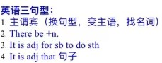
Task2：从句（条件和让步状语从句（if+ might, despite, as long as），there be定语从句，主语从句，强调句，分词，no matter especially that’s why）】 Task1 ： 主语丰富 there be, 想要描述的名词做主语 has increased dramatically，时间/地点 has witnessed dramatic increase,被动句（尤其是流程地图题）done/doing 做后置定语+定从, In which 等非限制性定语从句

the percentage/amount of coal→ 30% of electricity derived from coal is witnessed at the bottom of A. standing at 5. √=the electricity that produced by coal/due to… accounts for 30%, slightly higher than…(2)

→ In 2000 Australia used coal as the main electricity source (5), compared with B that…By/Until 2000, coal had become the fuel for more than 75% of electricity produced and …√
doing 结果状语， what 等
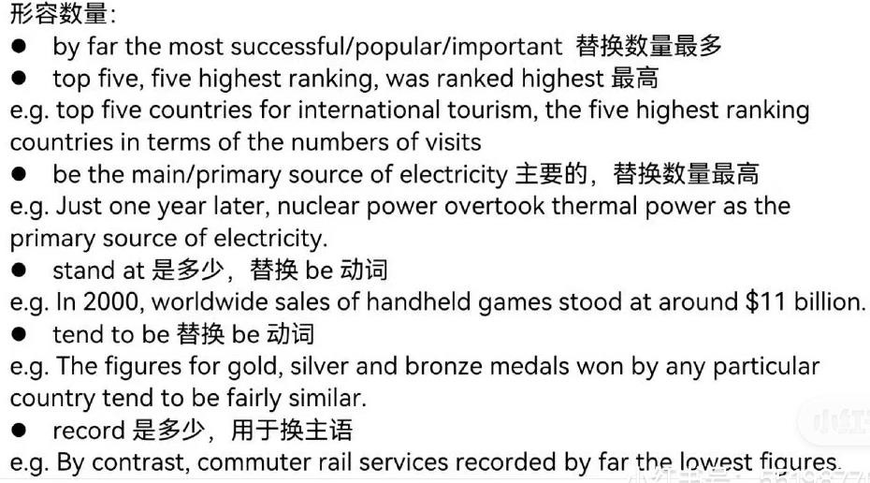
用 while, with, compared with, accompanied with,连接 2 个短句，一句话至少 2 个数据一个在定语一个在主体。努力同时描述多个主语
7，凑字数：多角度改写 idea：论证方法 67，即提分点 13 和正面改写

Link words！！
make XX more adj. 中式英语×→boost/Promote/enhance XX make it easier for sb. to do sth.
Exercise can build up=strengthen my body
enliven=spice up 使更有趣 rejuvenate 使变年轻 shrink 使更小 enlarge 使更大
Be conducive to my health=contribute to +beneficial to
Be harmful to= be detriment to = jeopardize (hinder block hamper suppress constrain refrain restrict limit
be accustomed to =get used to doing
Use👉capitalize on= utilize best/good/favorite/ideal👉coveted famous👉pride itself on Improve → optimize However→ while，whereas

Task1

图表

注意过去、将来时。Bar 转换成 line 来写。静态图多了倍数关系
必须明确主语 是 production、yield、sales data、design、spending/cost、waste 、electricity,而不是 smart phone 、国家、核电站

1，首句改写倒装。given/provided is a 图表 illustrating 等同替/ Illustrated in the 图表 is

①the changes/ variations in XX /the differences between XX and XX /

②how +the valuable information/ the details about/ concerning/ regarding XX / the number/data/amount/quantity/figure presented in XX/ figure for XX changes

③how many XX (the statistics) were consumed/produced/were emitted/shops opened yearly what the proportion/percentage of XX were consumed
+in 地点 disparate countries as for=in terms of=, including = specifically regarding 数据组…+between 时间的同替 + as well as projected / predicted figures for the year...（如果有将来时的话）

2，整体趋势：趋势分组描述(相同不同 continuously 升降 all the wa，保持稳定，波动)，最值（P4 和别人比最大的最小的主要的受欢迎的，自己比顶点底部），不变+排序；谁比谁高，正负相关无关(the amount/quantity suggest a strong positive/negative correlation/relationship between A and B, as one rises but the other declines
Pie 独有→最值(be dominated by)，a bit more diversity in。

Overall/ in general/generally, ○1 it is evident/noticeable from the two pictures ○2 it could be obviously witnessed in two picture that ○3 As can be apparently indicated from the two pictures,
…..that 上升+时间(../initially/the first/initial decade+ there be an considerable/ fluctuating upward trend / Co2 discharge/emission in 数据组 showcased/saw/experience a dramatic growth/maintain a consistent upward tendency in.. / The number of... experienced a slight/moderate/major decline/increase during.../ The rate of increase/decrease between... and... was considerable/ significant/ minor
while/ nevertheless/by contrast / On the contrary/whereas/conversely/ in comparison to that of/ only 10% of those doing
下降 there's a tendency to drop/ a downward trend in 数据组/the figure for 数据组 indicated a trend of decline / This population decline is a trend for 数据组+时间
A downward trend was clearly witnessed by the proportion of XX / 35% of XX was seen in ..
/35% was recorded for XX /the share/ small portion /distribution/ possession rate of 35% was recorded for XX
What ‘more/furthermore, 最值的表达 by far：XX produced the by far the most/lowest/least adj./ the largest amount/number of Co2 emission +时间/ Co2 emission is recorded by far the lowest/least amount of../figures / it’s ranking is by far the lowest/ tend to be by far the highest/ the top/ the primary/main source of../ ranks=comes= be ranked the

first/highest by far /the highest ranking belongs to= is found in XX ,reaching its bottom/peak point standing at..

主体：如何分段：单图且对象少：按照描述对象分段（the former and the latter）；单图对象多：按照趋势、高低、对象性质分段；多图：可上同，可按图分。每条线，每个组都要说到（学习同时说几个数据 the former.. the latter…）
3, ○4 Looking at/Upon analyzing /according to/based on/from/in/ the data presented in the form of 图表 the (first) diagram/picture, we can obviously/apparently/clearly see/conclude/ witness/observe in details that ○5 the chart/graph suggests/gives/offers the insight that……（合计 5 种表达看图的方式）
there be…used to be…, before which it saw a .. by.../followed by a .../with a ..following/and then/subsequently... Meanwhile…翻倍 to/顶点底部 at…as well/alike, although initially experiencing more modest growth from..to../while it remains the lowest/highest/minimal/maximal. Concerning the data of train users, it had a…
4, Compared to that/in comparison of XX/on the other hand /Turning to the second picture, according to/based on the quantity displayed in the graph, it can be palpable and noteworthy /clearly seen that, the figure for XX demonstrate an opposite tendency, rising from ..to…Similarly,…also..., despite to a smaller/larger degree/extent←找 2 条趋势和 3 相反，但是幅度不同的with projections indicating a further increase to about Y by 2040.

↓被动、一般时，完成时（once/until）

地图题

时间点如果是 in the present day 用现在完成时
1, (无变化) given/provided is a map illustrating what (a particular urban area/region/city) looks like +时间, involving various features such as structures, landmarks, body of water

and the like.

(有变化) given/provided are two maps illustrating /highlighting how (地方) will change notably/ what took place notably in(地方) from.. to …/displaying the estimated changes of(地方)+将来时间
2, ….that Over time/with the time goes on/with the passing of time, there will be several remarkable updates/developments, resulting in the layout/ landscapes of [地方] having changed insignificantly/ some great changes having token place, in which XX disappear/appear in 改变后的时间 but ... is/are well preserved.明显变化和不变的东西
3, Looking at/according to/based on/from/in/ the features presented in the form of picture in details, One notable feature of the map is the presence of XX in the south of the town, companied by….in a central region of X are four farms each with a new laboratory constructed. Additionally, there are several green spaces and parks scattered throughout the town, as well as a number of XX can be found.

During the period, the xxx area has experienced substantial growth and improvement, including A was replaced by B with D while C expanded/enlarged twofold/ C doubled in size. 4, In comparison of the southern part of the map/moving on to/turning to the second map, according to the changes demonstrated/ that have taken place in the map, it can be clearly seen that the north of the town seems to be more densely populated. In close proximity to xxx, one can find the yyy. Bordering the XX to the south lies the XX 南部与XX
接壤的是XX

Apart from that, a park has been developed/built/established/constructed to the north of the xx/in the western part of xxx, which is adjacent/opposite to B

流程图

必须写到每一步，时态一般现在时，被动

1，given/provided is a flowchart illustrating the valuable information about(同替同上) the process of/intricate/complex details of how sth. is done/ how to produce/create sth. and what raw materials and facilities are involved, providing a comprehensive overview of its components

2, generally,…(同上略)that the whole process can be meticulously broken down into at least/contain/consisted of totally 几个 distinct phases/process/stages/steps, starting from.. and ending at.. Each of these stages plays a pivotal role in the overall sequence-
34，材料+ be done + in/by + 工具
stages and steps:
…..that the first step of the first stage in the process/ procedure is to do sth and then to do sth. Subsequently in the third step, sth is done.
Following this, the second stage starts with/from doling sth, which is followed by doing sth. The next step in this stage is to do sth and then to do sth. Meanwhile/at the same time, After that/next comes third stage/at the third stage shown in the diagram, sth is done before doing sth.
The last stage includes 几个 steps: first to do sth and then to do sth. Only step:
… that the process starts from doing/n, during the initial phase, xx is done/, which is followed by doing sth. The third step starts with doing sth, where/ in which they stay for 2 days. After that/ after xx step / Following this, sth is done, before/after being dried for 2 days.
When/Once forth step is completed, sth is done until sth is sent to... After which/ in the subsequent step, sth is done. In/entering the final step, sth is done/ doing is the last step in the procedure, which makes the end/finished product/cycle
Once third step is accomplished/finished/completed / Upon completion of the third step, the process moves on to the final step. Specifically,…To complete the procedure, the finished/end product is stowed/ packaged in separate bags. Once the products have been packaged, they are delivered to the construction sites
循环的：最后加一句，The process recurrently loops back to the initial phase, ultimately contributing to /maintaining a continuous cycle of operation.

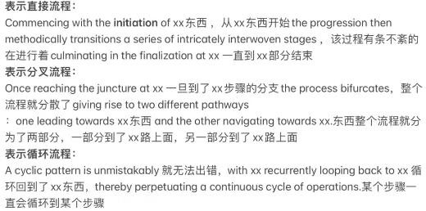
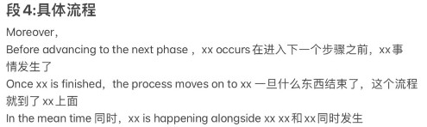

自然周期

1,Given/provided is a diagram illustrating the valuable information about how the XX is growing up and what happens throughout his life

2, Generally,…(同上略)that the whole life of （生物名称）contain/consisted of totally 几个 main life stages where We can obviously concluded that the complete life cycle lasts for 几 days between birth and death and the development of the..., from eggs to mature adult ...（如 insect, worm）.
3，…, the life cycle of the...begins when...(the female adult lays an egg). Between...and...days, later, each egg hatches and the immature... appears.
4，according to/based on the graph, it can be clearly seen that,….During the...stage of the life cycle, ...grows in size and weight/height.... ..., then...days later, After a total
of ...days from the start of the cycle, the young adult..., and days later it reaches full maturity

Text1 practice

柱状图：

The charts below show the main reasons for study among students of different age groups and the amount of support they received from employers. Summarize the information by selecting and reporting the main features, and make comparisons where relevant. You should write at least 150 words.

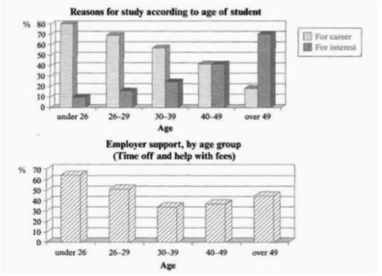
Given are two bar graphs illustrating the changes for the reasons/ disparate purposes why different generations choose to study and what the level/rates of corporate aid presented in the second one is, involving time and financial assistance for various age groups crowds/ranges/categories/ bracket ranging from below 26 to over

Generally, as can be apparently indicated from the two pictures, there is a considerate considerable decrease among individuals studying for career with the increase of/in age/ as they age/ as age increases/rises, while the folks individuals who are interested in study are getting more and more→ while the number of individuals interested in studying is increasing/those interested in studying are growing in number, where the group of under 26 is at the bottom compared with the over-49 group reaching the peak point. Furthermore, the companies demonstrate by far the strongest support for the younger crowd.

Upon analyzing the data presented in the form of those two diagram, we can obviously observe in details that the figures for the group learning for the development of occupation maintain a consistent tendency of
significant drop from fourth fifths to just less than one fifth. Similarly, the aid from the owners of firms experience a dramatic decline from the youngest group that receive the most to the bottom in the middle group, just over 60% and more than 30% , respectively. But after which, it has been climbing slightly by 10% until the last group.
In comparison, according to the quantity displayed in the graph, it can be palpable and noteworthy that a rapid opposite trend was observed in the proportion of the generation learning for interest, rising from one in ten to above two thirds. Meanwhile, the generation (aged) between 40 and 49 displays the same number in the purpose of both profession and hobby→ shares the same percentage for both professional and hobby purposes, standing at roughly 40%, and is given/receives approximately35% of assistance which is more/higher than the lowest bracket but less than the next one ( above 40%)/ receives roughly 10% more assistance than ←增加了同组的跨图对比,完整描述了一个组的全部信息

复盘：

1,首段尽量用上 what how why 全篇名词尽量不重复，还可以用 those ones that counterpart 替代。定从和分词短语形容主语。不断改主语。is increasing，have..until..

2,找到 2 个不同的趋势+具体描述顶点底部，也可以用 the strongest support/ popularity / the most popular 表述。主语有there be, 人，组，公司。这里升降用了名词
3,按照趋势分段写，相同的要写。主语有数据，公司的支持，it。 数字用了分数，百分数，from to, by,同位语 respectively。升降用了趋势 动词。
4, 主语有趋势，组。数字用了分词，display the same number in, at。升降用了动词。范文：
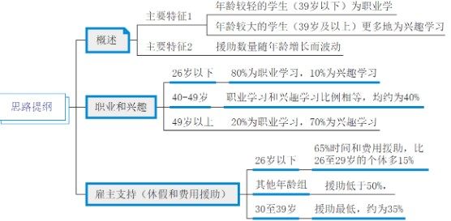
The bar graphs compare the rates of students belonging to various age ranges who pursued schooling 追求学业 for disparate purposes and illustrate the level of assistance given by companies.
Generally, in relation to 关于 age, the younger students aged under 39 study for career, while the oldest ones learn more for their interests. Also, the amount of aid provided oscillates with the increase in age.
Particularly, 80% of people below 26 years old study for career goals in comparison to only 10% of those doing schooling for interest. 数据放开头，自我比较 Nonetheless, as the age rises, the former lessens and the latter ascends, and they become equal in 40-49-year-olds, at roughly 40%. In those aged above 49, the rate of those learning for their occupation is much lower, approaching 20%, than that of those 比较的时候注意要主语一致 studying for their passion, reaching 70%.
Concerning the support bestowed, students aged below 26 are given about 65% of time off and help with fees, approximately 15% more than the level of individuals aged 26 to 29.
In the other age categories, the percentages of aid are all below 50%, with that of 30-39-year-olds being the lowest at only 35% or thereabouts.
对比分析：
本文是联动描述，
2,分析了图 1，在 X 组前是目的一，之后目的二。图二，属于波动
3，按图分组：图一分析每个年龄组：一个组的 2 个数据。随着年龄一升一减，到了 XX 相等。到了 XX 更低了 less than

2，图二:按照大小分组：比较前 2 组 more than; 其他都在 50%以下，其中XX 最低。

饼图

The following pie charts show the main modes of transportation people used to travel to university for work or study in 2004 and 2009. Please judge and select the key information in the chart and summarize it. If the information is related, please make the necessary comparison. You should write at least 150 words.
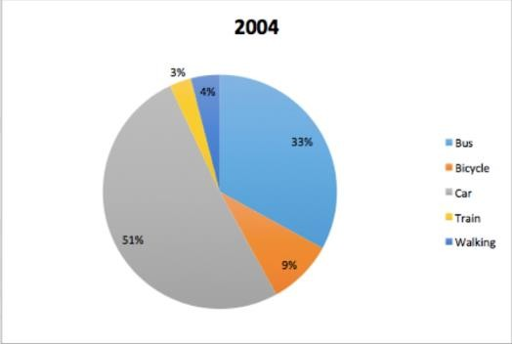
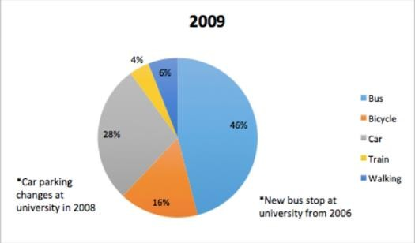
Given are two pie graphs illustrating the valuable information of how the residents commuted to college for work or learning purposes in both separate years of 2004 and 2009/ spanning half a decade due to the variation(多用于数据变化 changes of car parking and bus station.

Generally, as can be apparently indicated from the two pictures, an expanding number of individuals are more likely to/tend to travel to campus by bus, train, bike and even walking, while driving cars is less popular way to commuting in both years. Furthermore, although more people take train to study or work over the 5-year period, it remain the lowest one→ the least utilized method/ popular mode of transport in 2009.

Upon analyzing the data presented in the form of those two diagram, we can obviously witness in details that the percentage of individuals who prefer commuting to the aforementioned destination by bus displays a significant growth, rising from one third to less than two quarters, since a new bus station was constructed three years ago. Similarly, a considerable upward tendency was seen in the group of bicycle users 是人不是车→ the number of cyclists between 2004 and 2009, at approximately one in ten and

below one sixth respectively. Meanwhile, the figures for inhabitants who choose/choosing walking as the main/primary approach/means climbs slightly by 2% which is more than that of train in 2009(4%). 6% in comparison with 4%前文的主语没有顺序排序这样指代不明

In comparison, according to the quantity displayed pie graph, it can be palpable and noteworthy that there is only opposite trend /a sharply plunge from over half to merely 28% in the way of driving car→ amounting to 13% in the share of those using cars to 46% because the university parking had changed in after four years.
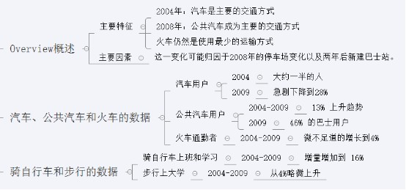
范文：

一个个描述每个分组，第三段分别描述，第四段最后 2 个一起写“the former and the latter” The pie charts compare the disparate means of transport for individuals going to a university for work or learning purposes spanning half a decade.
Generally,描述排序 the primary mode of traveling to the aforementioned destination differed, with it being cars in 2004 and buses in 2009, and the change could be attributed to the car park changes in 2008 and a new bus stop two years prior to that 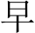两年. On the contrary, trains remained the least utilized method of transportation.

To be specific, roughly half of the people proceeding to the campus drove cars in 2004, but the figure drastically lessened to merely 28% in 2009. By contrast, there was a noticeable uptrend amounting to 13% in the share of those using buses to 46%. turning to/ Concerning the data of train users, it had a trivial growth to 4%.
In addition to previously stated means, riding a bicycle 动名词和名词替换 and walking to the university were also done by workers and students. The percentages of both became more sizeable, with the former experiencing a comparatively greater level of increment to 16%, whilst the latter ascended marginally from 4%.←两个数据同时描述“前者后者”

折线图

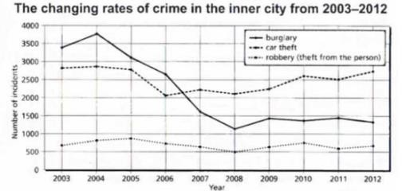
最简单，每条线分别描述，特征多的一段，少的两个一起，前后者。如果可以找到明显的对比趋势，就按照趋势分两段。本题特点：很多持平的数据
Given is a line/curve graph illustrating the variations about how much three cases of crimes is in Newport’s town center spanning a decade from 2003 to 2012.
Generally, as can be apparently indicated from the pictures, the three criminalities experienced fluctuating trends, with the rate of burglary decreasing dramatically during the period. In contrast, robbery was committed the least/most in this area in those years.= The data for robbery display a minor fluctuation between 500 and 1000 and it remains the lowest/least among all types of crime spanning the decade from 2003 to 2012
By analyzing the data presented in the form of this line diagram, we can obviously witness in details that burglary offenses had a total number of almost 3,500 incidents in 2003; they experienced a minor climb to less than 4,000 in 2004. Afterward, there was a significant decrease in burglaries, reaching its bottom at over 1,000 cases by 2008. In the following year, it rose minimally and almost remained at the same level until 2012.
Compared to that/ In comparison, according to the quantity displayed in the curve graph, it can be palpable and noteworthy, from 2003 to 2005, the figure for car theft and robbery cases nearly stayed at the same point, with approximately 2,800 and above 500 occurrences, respectively. However, in 2006, the former felony dropped gradually to around 2,000, while the latter fell erratically to 500 cases in 2008. In the succeeding years, auto theft instances fluctuated upwards and became the most committed crime in 2012, when they reached a similar number as in 2003 自我比较. In comparison, robbery incidents had roughly leveled off over the last six years.

表格

The table below gives information about the underground railway systems in six cities. Summaries the information by selecting and reporting the main features, and make comparisons where relevant. Write at least 150 words.
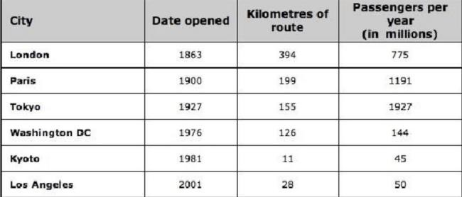

Given is a sorted graph illustrating some valuable statistics concerning the subway networks in various urban regions, in terms of/ specifically regarding the opening dates, the lengths/distance of routes and passengers flows

Generally, as can be apparently indicated from the chart, the metro system was constructed earliest/first in London with the longest line by far, followed by Paris, Tokyo and Washington DC in that order= successively, as well as that in Los Angeles →Meanwhile the system in Los Angeles tends to be by far newest among /of these six areas. Furthermore, Kyoto ranks/ is ranked sixth in both categories/ aspects, regardless of whether it’s about the length of the line or the passenger volume is considered and Washington has the same fourth ranking in these same aspect as well
Upon analyzing the data presented in the form of this sorted diagram, we can obviously observe in details that there are four subway routes whose length is/traveling over 100 km s , where that in London is roughly twice as long as that in Paris, →where specifically, the London route tends to be approximately twice as long as the Paris route/ the railroad line, measuring/ traveling /covering/with the distance of 394km and 199km respectively, compared with 11km in Kyoto and 28km in Los which all both cover below 50km each.
In comparison, according to the quantity displayed the graph, it can be palpable and noteworthy that the by far largest passenger flow is found in/ belongs to /tends to be that of Tokyo (1927 million s every year), followed by Paris with 1191 million s per year. Besides that, the passenger flows volume in Kyoto reaches the similar number as/tend to be

similar to that in of Los, at 50 million a year. →the passenger flow volume in Kyoto is comparable to that of Los Angeles, reaching a similar number of passengers per year (50 million).
范文：
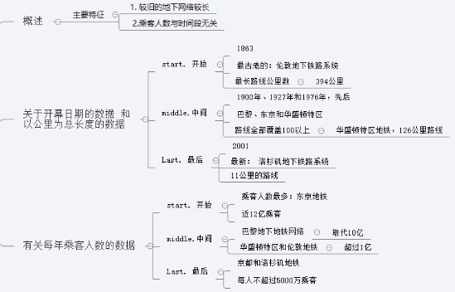
思路对比：
overall 段，我用的是排序，更简单；范文是分析两列的关系，更好
主体：我：一段一列，长度：100 上和以下；客流量第一第二和 2 个差不多的范文：也是 100 上下分 2 组，最新最短最长作为定语修饰；
按顺序分别说第一第二和合并差不多的数据，in the other 把每个都列举下，本题特点：很多除了，例外

The chart provides statistics regarding the metro rail network in various urban areas.
Overall, except for the data of Kyoto and Los Angeles, the older the underground system is, the longer the distance it covers. 排除 2 个意外其他有线性规律 As for=in terms of the annual 每年 number of passengers, it does not directly correlate with the other two aspects. 无关
Particularly, the railway that opened first and the longest is the one in London, starting its operation in 1863 and traveling 394 kilometers. 同时描述多组数据 The rail networks in Paris, Tokyo, and Washington DC were established in 1900, 1927, and 1976, successively= separately =respectively, and their routes all cover above 100, although the latter was only 126 描述最少一个. Despite that of Los Angeles being the newest, opening in 2001, the kilometers traveled by that in Kyoto, inaugurated two decades prior（to that 二十年）, is the shortest at 11.
On the contrary, such railway system in Tokyo has the highest number of passengers, at almost 1.2 billion, followed by that in Paris, which is the only one 唯一 that superseded 1 billion. While those in Kyoto and Los Angeles only move no higher than 50 million each 合并数据, the tubes in the other two cities carry more than 100 million individuals per annum每年, separately

地图

The map below is of the town of Garlsdon. A new supermarket (S) is planned for the town. The map shows two possible sites for the supermarket. Summarize the information by selecting and reporting the main features, and make comparisons where relevant. Write at least 150 words.
Given is a map illustrating where the two planning/proposed locations of for a new supermarket are in the town called of Garlsdon with a residents of 65000.

Generally, as can be apparently indicated from the picture, S1 is situated between two main transportation routes, the subway system and roads, making it easier to access/making it more accessible for residents than S2 passing close by /which is located close to only one rail route/ within reach of the railroad line. Conversely, these two possible/ probable /likely/ potential area are all sited fay away → a considerable/minor distance from industries/ the industrial region in both north and south.←按图算近

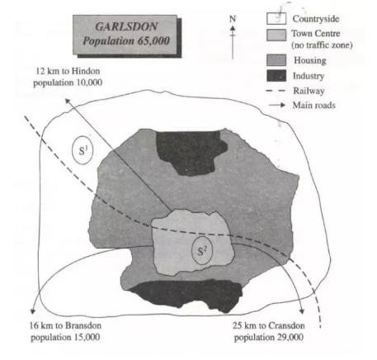
Upon analyzing the valuable information/location/progress presented in the form of the picture, we can obviously observe in details that one notable feature is the presence of S1 in
rural area, the northwest of the town, 同位语 while S1 is adjacent to Hindon, a town with 10000 of population 10000 dwellers 数字放前面, situated approximately 12km away.

In comparison with of the northwestern part of the map, according to the changes demonstrated/ that have taken place in the map, it can be palpable and noteworthy that in the downtown area of the region is a not traffic section/region= a place where driving is restricted surrounded/encircled by a large dwelling/ residence zone where another probable placement, S2, is established, accompanied by Bransdon, with a population of 15000 and Cransdon, with a population of 29000/ having inhabitants of 15,000← 口语中数字才可放前面，书面语中定语后置, located 16km and 25km, respectively/ successively, away from S2.

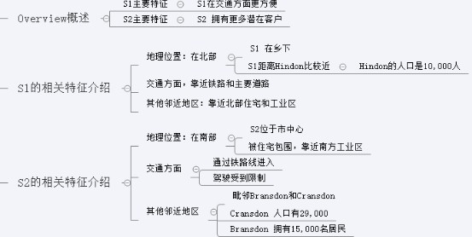
范文：
Illustrated in the map are the likely locations of a new supermarket in Garlsdon, a town with a populace of 65,000.

Generally, in terms of convenience in transportation, S1 is a better option, but considering the number of possible customers, S2 is a good place for the new supermarket.←更好
It could be easily seen that the first possible site (S1) is situated in the countryside, the northwest of the area, and between the railway and the main road leading to Hindon with 10,000 residents. It is also near some sections of the housing region and the industries in the north. The concern about this location is that it is distant from the other neighboring towns.
On the other hand, the second probable placement (S2) is in the southern part of the town center, encircled by the residences and in the vicinity of the industrial region. While it is also within reach of the railroad line, it is in a place where
driving is restricted. Meanwhile, the main roads are directed to the adjacent places, like Cransdon (population of 29,000) and Bransdon, having inhabitants of 15,000, ending at the boundary of the center.
室内 layout 题见 PDF -overview

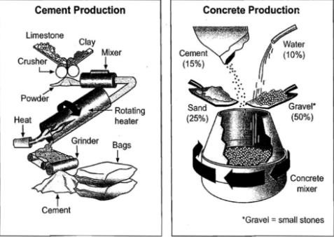
流程图

The pictures show the production of cement and concrete. Summarize the information by selecting and reporting the main features and make comparisons where relevant. You should write at least 150 words.

Given is a flow diagram/flowchart illustrating the valuable information about the intricate details of how to produce cement and concrete, and what raw materials and facilities are involved, providing a comprehensive overview of its components

Generally, as can be apparently indicated from the two graphs, the whole process of cement manufacture can be meticulously broken down into at least/is consisted of totally five distinct phases, starting from crushing and ending at packaging in the first picture. And there is a total of two processes during the concrete production in the other one. Each of these stages plays a pivotal role in the overall sequence.

Upon analyzing the steps presented in the form of the two diagrams, we can obviously observe in details that the process starts from/begins with preparing limestone and clay, and then put them into the crusher →which are then crushed and converted into powder. After which/ Following this, these materials can be combined/ blended in the mixer and subsequently be transported to be heated 被动强调本身被加热 passing in a Rotating heater/ transported to a Rotating heater for heating/ transported, passing through a Rotating heater for heating. Once the third step is accomplished/finished / Upon completion of the third step, the process moves on to the final step. Specifically, the heated material should be manufactured to cement, after having been ground completely. To complete the procedure, the finished/end product/commodity is stowed/ packaged in separate bags.

According to phases displayed in the other flowchart, it can be palpable and noteworthy that during the initial phase, the four kinds of items (15% of cement, one in ten of water, one quarter of sand as well as half of gravel 加不加可以，但是如果强调水泥总量的 15%则必须加 of)/the mixture of 15% cement… should be placed to in a rotating concrete mixer and blended thoroughly, until concrete is created ultimately/ eventually.

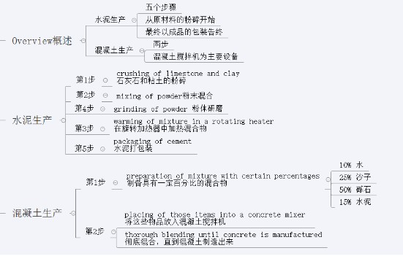
范文：
The diagrams illustrate how cement is produced and is ultimately used to manufacture concrete.
All in all, five steps are taken, commencing with the pulverizing of the raw materials and culminating in the packaging of the finished product, to make cement. Regarding concrete production, only two things are done, with a concrete mixer as the main equipment, but certain proportions of the materials are imperative.
To begin the making of cement, limestone and clay are crushed into powder, which is subsequently placed into a mixer connected by a pipe to a rotating heater, where the mixture is made warm. After being heated, the powder is ground to finally produce cement 我们更关注的是研磨粉末的动作是为了生产水泥，
而不是粉末本身被生产所以不用被动
. To complete the procedure, the
finished product is stowed in separate bags.
In terms of concrete, its mixture is comprised of 15% cement, 10% water, 25% sand, and 50% gravel. These items are placed into a concrete mixer, and after being swiveled, ensuring that they are thoroughly blended, concrete is eventually manufactured.

Task2

1, discuss both, agree or disagree, advantage, positive trend

开头：In our contemporary era, an ever-growing/ expanding /augmented/ amplifying/increasingly of newspaper headlines/ the public issues have emerged as a focal point, highlighting the debate whether/where (改写题目论点) , thereby capturing significant attention from diverse sections of society.
it is undeniable that（简单写一个反方支撑理由）….,which has led some individuals/ a segment of society to firmly believe that(改写题目反方观点)…Whereas/Conversely this statement suffers from both logical and factual fallacies, and it should be examined meticulously. In terms of X, X and X/Despite recognizing the merits and drawbacks behind the viewpoint, I definitely/strongly hold that…(别的用这个)/I definitely endorse/ am in favor of this standpoint that (agree 用这个)we should prioritize (改写题目本方观点).(举例 xxx brings substantial/concrete benefits), which is supported by cogent and well-founded arguments.( 遇到题干问是否是最佳手段时，可以说“should not be overvalued”
(不一边倒用这个: This essay will meticulously delve into both sides of the argument before cementing a personal viewpoint.)

主体 1：First and foremost, the justification for my preference for the first viewpoint is grounded in solid reasoning, particularly regarding/in relation to xxx.(e.g. Environment, society stability, economic advancement...), regardless of whether it’s..or..is considered
Explanation: This stance is strongly rooted in the conviction that….. /The rationale behind this is rooted in the fact that… /This belief is based on the fundamental idea that…/This is due to the fact that…./This mainly because…. (说理句式)which means that…..especially
What’ more, it holds a significant weight in modern epoch/society

必须有 example→ To be more specific, this can be best illustrated by the following example/ A detailed analysis./ To expound, as a case in point/ To illustrate,
①A recent research in relevant area/field conducted by（研究机构要编:例如XX University, Beijing Academy of Environment and Science, 编一个与主题相关的机构） has found that/brought to light that….然后写你编的这个研究成果(举例 there is a clear negative/positive correlation between A and B, indicating that the higher…. and the lower/more …/the present dilemma of XX in china are getting increasingly serious, and../ “香港大学做过一个研究结果显示接受过教育的青少年罪犯在出狱十年后比没接受过教育的罪犯重新犯罪的可能性低 50%A study conducted by the University of Hong Kong showed that educated juvenile offenders were 50% less likely to reoffend than uneducated offenders after 10 years of release from prison”) , fueling extensive public fascination and arguments/attention and debate.
②As exposed by the most up-to-date government report/ an up-to-date government report exposed/ Numerous worldwide studies have shown that/ as asserted in the latest governmental report,…(举例 many XX in china have benefited a lot through/suffered a lot from XX, and an increasing amount number of others are trying to do so/refusing to do), sparking widespread public curiosity and discussion
③如果举人的例子，注意普遍性，加上修饰词， To illustrate, Take a general/universal example/ case of a typical XX among thousands/ who is similar with others/ who is the same as everyone else, …..

加一句虚拟/倒装
Consequently, From what I understand, it is certain that XX can be considerably beneficial in the terms of （观点浓缩,扣题）
主体 2 让步：Nevertheless, it should be pointed out that this pattern of viewpoint/belief is not without its own downside, especially when things are not going in the way they imagined. Admittedly, it is hard to deny that (改写首段的反方支撑理由)…., suggesting that(改写题目反方观点)….
（Specifically, xxx.）(如果是 both 题目就加这句，用虚拟语气多分析反方一句，)
Conversely, based on what I have observed/from my perspective/ standpoint/my point of view, it seems that A/B/C 中选一个
A.反方说自己的优点，以下 3 选一
- Compared with this insignificant/minimal advantage, the disadvantages of XX are substantially apparent
- The benefits of this phenomenon is temporary, not long-lasting.
- The audience group is in a tiny minority.
B 反方说我方缺点，以下 4 选一
- 上面优缺点换下
- This is a rare occurrence that is not universal.
- If the argument is carried out in this way, it is probable that the outcome will be less favorable than might be expected.
- It is indeed possible that this might occur in a few instances. However, it can also be readily resolved at a relatively/ substantially low economic and time cost. C From a detailed analysis, such as the extensive research conducted by xxx, corroborates that xxx (←不一边倒
Explanation 分析我方观点:To deepen this elucidation/Delving into deeper/ To expound/ This/which means that/That is to say/In other word,
+上段的(说理句式)(举例 In the majority of cases, for the ordinary person, it is a challenging achievement.
+说理，论证方法 6(if….虚拟 B-3/…otherwise…/倒装) +或者 example 3 种: as a case in point, (举例)…

Therefore/as a result, It is only through (细化论点 2，扣题)…that we are able to ….and the merits/advantages of XX are of obviousness./ such problems/dilemmas are to be solved through appropriate management of…

主体 3（进一步支持本方观点有时间写）On top of that/ Apart from/Furthermore, the evidence suggests that…, indicating/demonstrating that+句子/due to the fact that…Specifically, xxx 缩小范围 Meanwhile/in the meantime/in addition/no to mention that
similarly, ... be more likely to……while…句内.leading to … on the other hand（说理、举例或反例 By contrast/ in comparison
虚拟 Obviously, if we want to do XX, it would be much better to take the advice of 采纳 and put a special emphasis on the improvement of XX/there is no doubt that enough concern should be paid into the problem of XX. +倒装 had it not been for X, A would never（和结果相反,）…/Only in this way can way…只有这样我们才能

结尾 In a nutshell/To summarize, In light of what I have mentioned above, the recapitulate in short /I remain unwavering notion in my conviction that(本方观点) …
while potential pitfall lurk in the backdrop, the arguments I have elucidated above robustly vindicated my stance/Despite the potential challenges and changing circumstance, the point I have outlined support my viewpoint convincingly

凑字数：As long as human nature remains imperfect, conflicting views will persist, and some may disagree with my perspective. However, I am confident that through exposure to my arguments, even those who hold opposing views may come to a compromise./ Even though there may be differing opinions/perspectives on the subject, I am confident that my opponents will be convinced by what I have presented/ by the evidence presented in my articles

2, report

开头：In our contemporary era, an expanding /augmented/ amplifying/increasingly of newspaper headlines/ the public issues have emerged as a focal point, highlighting the trend where (改写题目论点) , thereby capturing significant attention from diverse sections of society.
The phenomenon is palpable and noteworthy, which need to be explored and spotted. This essay aims to delve deeply into the underlying reasons driving (problems/dilemmas caused by) this occurrence and suggest concrete solutions that could potentially ameliorate the issue effectively and efficiently.
在当今时代，xxx 的主题已成为焦点，引起了社会各界的极大关注。（改写题目）的现象是显而易见的和值得注意的，必须加以探索和发现。本文旨在深入研究导致这种情况的根本原因（由此引起的问题/困境），并提出可能有效和高效地改善问题的具体解决方案。

理由 From what I understand, there could be several reasons for /loads of present dilemmas caused by this phenomenon, one of which is
问题 Unfortunately, based on what I have observed, it seems that there could be loads of potential dilemmas caused by this phenomenon, one of which is/ no matter how convincing the above/individuals’ motivations are, problems still emerge along with this custom.
必须有 example→略 参考上个模版的 3 个

A: (原因/问题 1)one of which is that, a primary catalyst why/ for this concern is xxx, a fact that can be rooted in the key understanding that…. Particularly….
这种担忧的主要催化剂是 xxx，这一事实可以植根于 xxx 的关键理解。
A primary/main outcome/effect resulting from this sort of conduct is environment destruction, which can be rooted in the conviction that…. Particularly…. As consequence,…(扣题)
(原因/问题 2)Another substantial factor contributing to the escalation of this problem is xx, chiefly attributable to xx(changes of in/efforts 结果/products that resulted from YY. (Another related/relevant consequence is that…) which means…that could result in YY.
导致此问题升级的另一个重要因素是 xx，主要归因于 YY 导致的 xx。
…. including …, but not limited to. Therefore, (扣题)
In other words, If.. might not…they might find it adj. to do … 假设+虚拟 had it not been for X, A would never（和结果相反,倒装）
B: 原因 one of which is that/One reason why 犯罪 is that+原因 1；Another cause behind it is that+原因 2；原因 3+be also to blame for 犯罪行为：原因 4+is possibly another responsible factor contributing to 犯罪行为; another compelling reason is that…

(字数不够，on top of that. Generally speaking, Apart from that, To deepen this elucidation/Delving into deeper/To be more specific,

方法：Considering the severity of the issue, in reaction to these precipitating elements and a amplifying number of consequences resulted from the escalation of these problems, it is essential that effective resolutions/measures should be taken/approved to tackle the problems/dilemmas/obstacles/ difficulties/ challenges./ X can take steps to mitigate these potential problems (and put special emphasis on the improvement 进展 of XX)
必须有 example→ To be more specific, as asserted in the latest governmental report, xxx. 正如最新的政府报告中所断言的那样，说明 xxx。略 参考上个模版的 2 个

具体步骤：
A: Foremost among these is the imperative to xxx. The fundamental responsible supporting this proposition is xxx. 其中最重要的是对 xxx 的命令。支持这个命题的基本推理是 xxx。Furthermore, there is a crucial requirement to xxx, with the reasoning for this strategy rooted in xxx. 此外，对 xxx 有一个至关重要的要求，这种策略的理由植根于 xxx. which means that/That is to say/In other word, this can be done by offering support in terms of XX to those who study hard 被动句。
B: At the personal(A)level,…At the government(B)level, they should take steps to, involving financial incentives(刺激) are given to…
C: First and foremost, a simple solution for the government/societies should be taken/approved to increase…. through appropriate management of…Apart from that/other than that, XX should be encouraged 被动 …(Lastly, the most desirable preventative measure against X (crime) is that… )
D: 1it is an effective and practical way to 减少犯罪 as+原因 1；
the most desirable preventative measure against crime is that+方法 2 as+原因 2；方法 3 +is possibly a solution to crime as+原因 3：
方法 4 +is another method to .. on one hand…on the other hand…

凑字数:Although this phenomenon have some positive/negative influences, I firmly believe that I should be seen as harmful/positive

结尾：To summarize/in a nutshell, despite the present dilemma, that/in which/which involves (改写题目),非限制性定从前后要用逗号隔开 is incontrovertibly multifaceted and intricate issue with an array of underlying causes and wide-ranging consequences, it is still imperative to acknowledge that what we need to consider is how to accept this trend as positive/ how to turn this trend to a positive one while simultaneously staying away from /avoiding its drawbacks. In light of what I have mentioned above, I am convinced that this calls for a joint effort from all sectors of society, and each of us has a role to play in this process/the measures taken would be more likely to bring about the desired improvements.总而言之，尽管 xxx 的困境是多方面和错综复杂的问题，具有一系列根本原因和广泛的后果，但我们仍然必须承认，我们需要牢记的是如何接受这种趋势是积极的/如何将这一趋势改善为积极局面，同时远离它的缺点。鉴于我上面提到的情况，我相信这需要社会各阶层的共同努力，我们每个人都可以在这一进程中发挥作用/这些变化更有可能带来预期的改进。

凑字数：While there may be differing opinions/perspectives on the subject, I am confident that my opponents will be convinced by what I have presented/ by the evidence presented

in my article

Report 模板示例

看蓝色部分就行，文章论点论据内容随便写的
In many countries today people are living in a ‘throwaway society’ where things are used for a short time and thrown away. What do you think are the causes of it and what may it lead to? 原因+问题

In our contemporary era, an expanding /augmented/ amplifying/increasingly of newspaper headlines/ the public issues have emerged as a focal point, highlighting the trend where (改写题目论点) currently individuals /the greater masses have been living under a kind of society where individuals just preferring to utilize what they need for a short period and then dispose of them these items, thereby capturing significant attention from diverse sections of society.
The phenomenon is palpable and noteworthy, which need to be explored and spotted. This essay aims to delve deeply into the underlying reasons driving this occurrence and the potential dilemmas caused by this public phenomenon and suggest concrete solutions that could potentially ameliorate the issue effectively and efficiently.
原因
From what I understand, it is certain that there could be several reasons for this phenomenon, one of which can be rooted in the key understanding that/ a primary catalyst for this concern is stress, a fact that can be rooted in the key understanding that these years the increasingly number of individuals, especially young crowd, have been living in the rapid-paced environment in the face of various responsibilities and daily chores, contributing to the amplifying need of convenient items which can save money and energy for other activities. Take a classic example of the one-time packages the disposable plastic packages/the single-use food packaging, after having meals, individuals just need to throw them away without washing dishes, spoons, forks and the like, particularly in outdoors where it is hard to find clean water and suitable kitchen utensils. Moreover, it must be realize that in most circumstances, the disposable items are cheaper than other ones with high quality, reducing living cost. As a consequence, majority of individuals tend to use these kinds of products for a short time(扣题)
Another substantial factor contributing to the escalation of this problem is herd mentality/ group/ crowd psychology, chiefly attributable to excessive advertisements. Every age groups are surrounded by a diverse range of advertisements and can see them no matter where they are, regardless of whether they are scrolling on social media at home or waiting in the subway station, making it more accessible to acquire up-to-date information about latest commodities, including electronic devices like smart phones and robot vacuum cleaners, but not limited to. Therefore/Because of this/Owing to this, (扣题) individuals of all ages tend to frequently purchase something new or updates what they have had/existing objects to keep up with what is trending recently and boost overall living standard. Furthermore,(虚拟) if almost all of their circle have weeded out/left something outdated, they might be likely to buy the latest products in the attractive advertisements like who are around them due to peer pressure.→其实可以拆成 2 个理由，广告的引导和科技迭代快改善生活
问题
Unfortunately, based on what I observe, it seems that there could be loads of potential dilemmas caused by this phenomenon, one of which is/ no matter how convincing the above/individuals’ motivations are, problems still emerge along with this custom. A primary/main outcome/effect resulting from this sort of conduct is environment destruction, which can be rooted in the conviction that the more frequently they buy the new products and throw the old ones, the greater quantities of garbage they would produce, and then it is

necessary to waste more energy to cope with these wasted resources, like burning them by the fossil fuel which lead to air contamination, or fill them into underground which result in land pollution and is harmful to the use of land for more essential activities like food cultivation may take up other green space like farms. To deepen this elucidation/ Delving into deeper, this can be best illustrated by the following example, a recent research in relevant area/field conducted by Beijing Academy of Environment and Science has brought to light that there is 50% land that is appropriate for planting grain and crop used to be a place for filling waste in the last ten years, fueling extensive public fascination and arguments Another related/relevant consequence is that people become overly materialistic, which means that they fail to recognize what is important as they unreasonably indulge in unnecessary expenses, which could lead to/ result in selfishness and sometimes endless debts in the end. In other words, If.. might not…they might find it adj. to do … 假设+虚拟 AS a result, 倒装 had it not been for X, A would never 和结果相反
措施
Considering the severity of the issue, in reaction to these precipitating elements and a amplifying number of consequences resulted from the escalation of these problems, obviously it is high time to put an end to the trend. Because of this, / it is essential that several effective resolutions/measures should be taken/approved to mitigate/alleviate these potential problems/tackle the problems/dilemmas/ obstacles/ difficulties/ challenges (and put special emphasis on the improvement 进展 of XX)
Foremost among these is the imperative to launch some education campaigns and outreach activities for preaching the significance of environment protection. For example, children could be taught about how to protect ecological environment in class, and homeowners could be informed of the environmental impact of household waste. The fundamental responsible supporting this proposition is the right awareness and conception can guide appropriate daily conducts. To expound, as a case in point, as asserted in the latest governmental report, hosting publicity campaigns to raise public awareness and regulate the behavior of citizens can alleviate population effectively and efficiently, sparking widespread public curiosity and discussion.
Furthermore, there is a crucial requirement to the corporations, with the reasoning for this strategy rooted in their responsibility for society and the environmental sustainability. To be more specific/ which means that, this can be done by introducing laws to limit/deter/discourage contaminant emissions from factories or to forcing firms to utilize renewable energy from/ in terms of solar, wind or water power and more/and others/and so forth/ and the like/ or whatever (to those who..)
Last but not least, the most desirable preventative measure against wasted resources is that there could be punishments for people who fail to adhere to the regulations about household waste sorting, ranging from a small fine to community service, or even perhaps prison sentences for repeat offenders.
As a consequence/ Consequently, only in this way can we…
结尾
To summarize/in a nutshell, despite the present dilemma, where that/in which/which involves (改写题目), is incontrovertibly multifaceted and intricate issue with an array of underlying causes and wide-ranging consequences, it is still imperative to acknowledge that what we need to consider is how to accept this trend as positive/ how to turn this trend to a positive one while simultaneously staying away from /avoiding its drawbacks. In light of what I have mentioned above, I am convinced that this calls for a joint effort from all sectors of society, and each of us has a role to play in this process
凑字数：
While there may be differing opinions/perspectives on the subject, I am confident that my opponents will be convinced by what I have presented/ by the evidence presented in my articles

Example：

